Test Case: tc006_SPX_Dev5_Crear_Requisicion_Spot_Tipo_Cobro_Proyect_Urgent
Step 1 - Enter username and password and click to button Enter: Credentials Entered
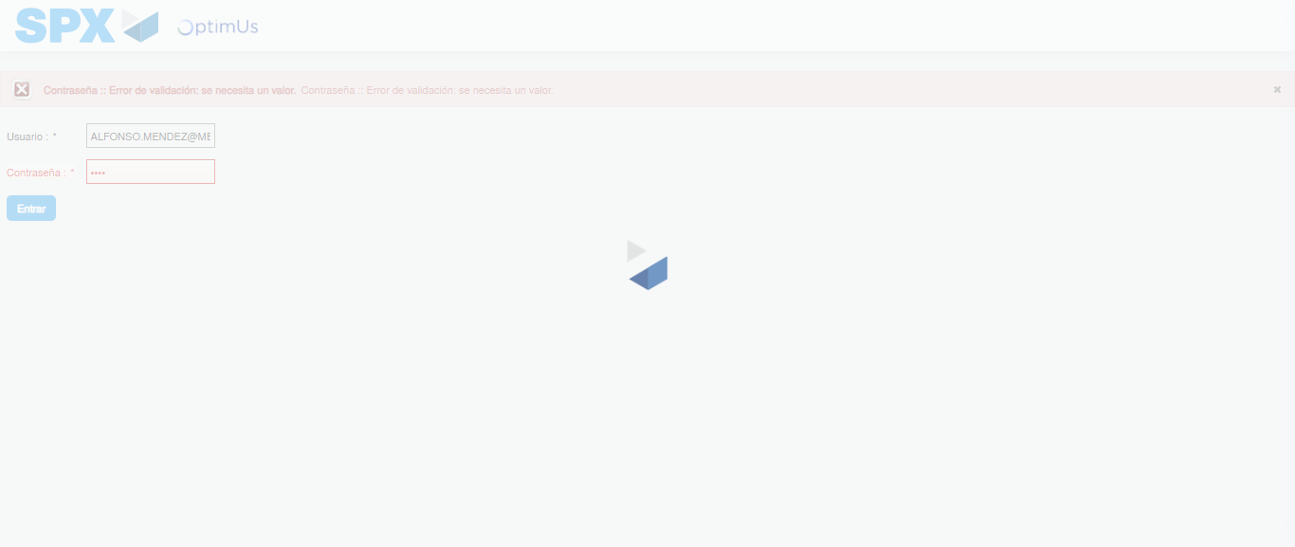Image file-name: QC_Testing-tc006_SPX_Dev5_Crear_Requisicion_Spot_Tipo_Cobro_Proyect_Urgent-1783374546758

Step 2 - Select to UEN and Access to Spot Buy Requisitions : UEN Correctly selected and Correct access
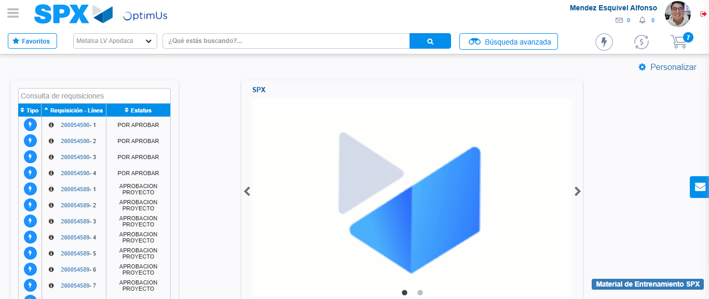Image file-name: QC_Testing-tc006_SPX_Dev5_Crear_Requisicion_Spot_Tipo_Cobro_Proyect_Urgent-1783374592335

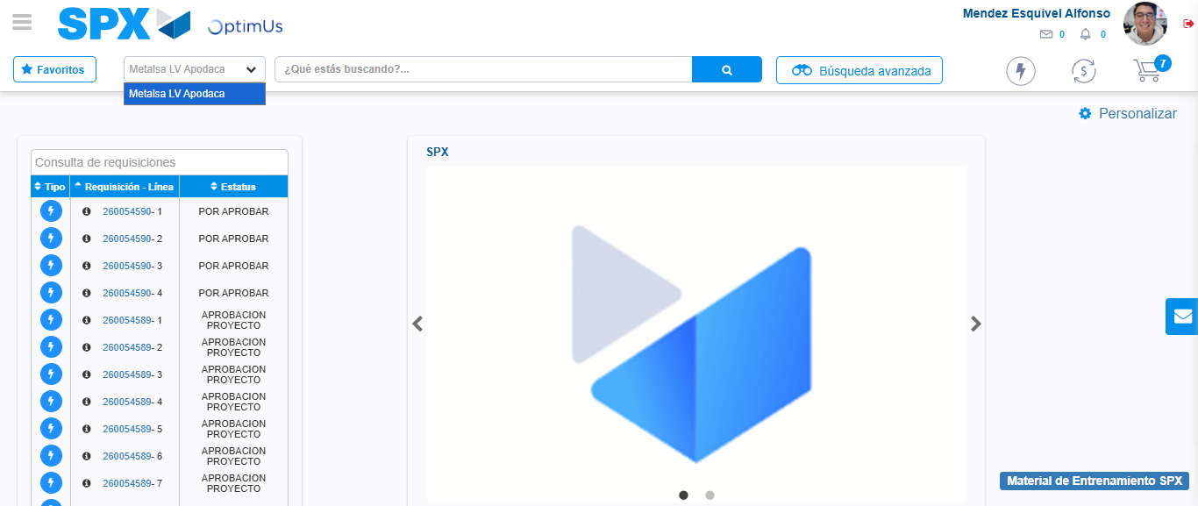Image file-name: QC_Testing-tc006_SPX_Dev5_Crear_Requisicion_Spot_Tipo_Cobro_Proyect_Urgent-1783374594912

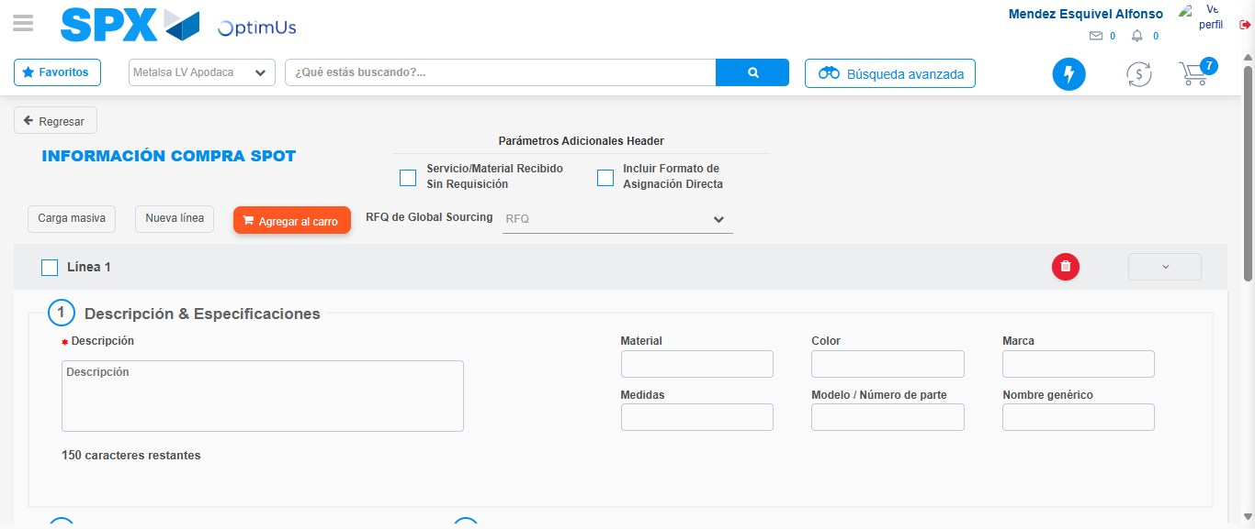Image file-name: QC_Testing-tc006_SPX_Dev5_Crear_Requisicion_Spot_Tipo_Cobro_Proyect_Urgent-1783374602202

Step 3 - Data Capture Spot Buy Requisition: Data captured correctly
Image file-name: QC_Testing-tc006_SPX_Dev5_Crear_Requisicion_Spot_Tipo_Cobro_Proyect_Urgent-1783374602397

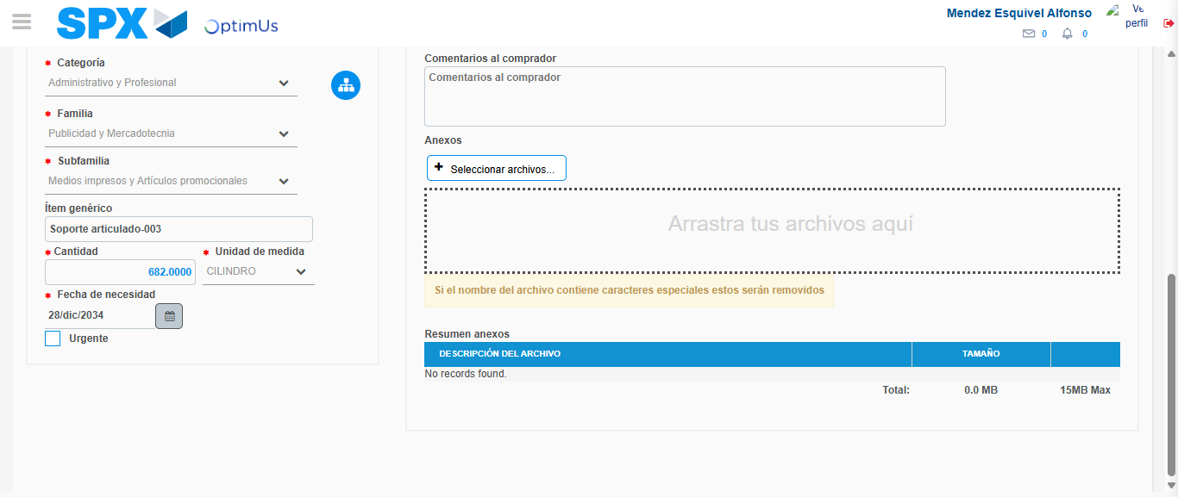Image file-name: QC_Testing-tc006_SPX_Dev5_Crear_Requisicion_Spot_Tipo_Cobro_Proyect_Urgent-1783374612928

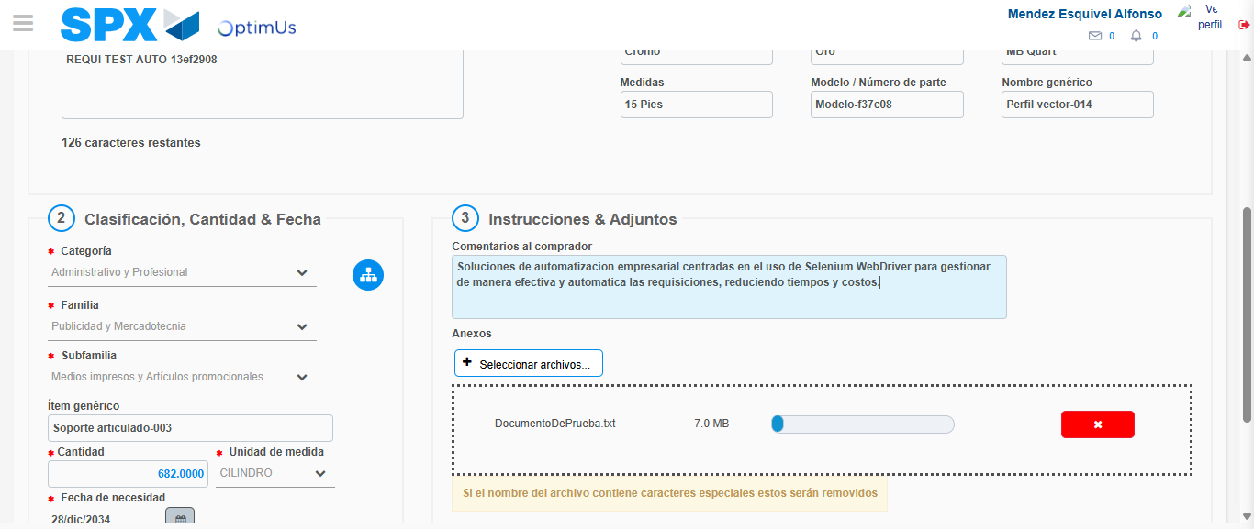Image file-name: QC_Testing-tc006_SPX_Dev5_Crear_Requisicion_Spot_Tipo_Cobro_Proyect_Urgent-1783374613692

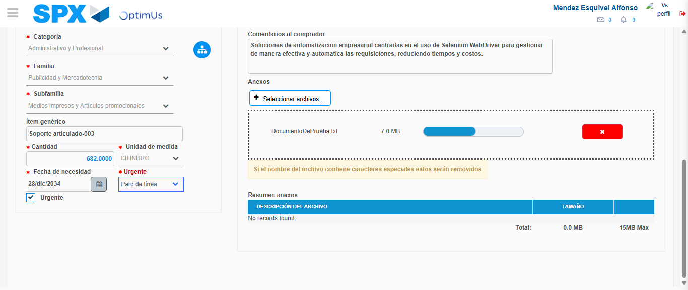Image file-name: QC_Testing-tc006_SPX_Dev5_Crear_Requisicion_Spot_Tipo_Cobro_Proyect_Urgent-1783374616780

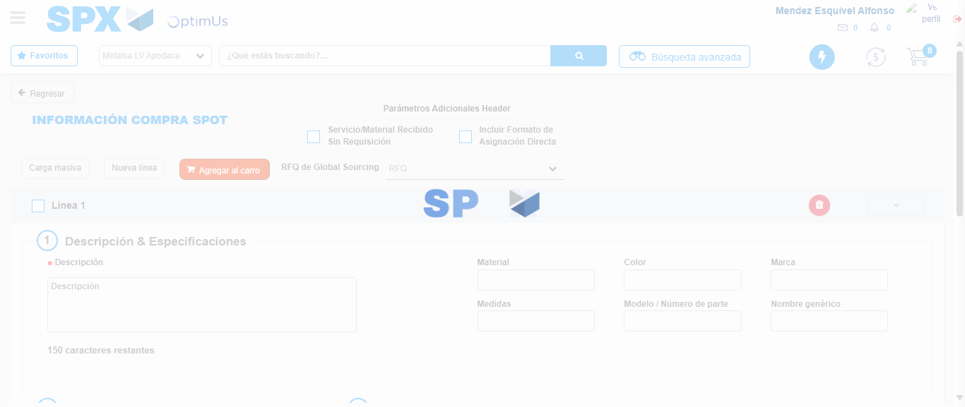Image file-name: QC_Testing-tc006_SPX_Dev5_Crear_Requisicion_Spot_Tipo_Cobro_Proyect_Urgent-1783374624197

Step 7 - Return to Main Page SPX : Return to Main Page SPX
Image file-name: QC_Testing-tc006_SPX_Dev5_Crear_Requisicion_Spot_Tipo_Cobro_Proyect_Urgent-1783374592335

Image file-name: QC_Testing-tc006_SPX_Dev5_Crear_Requisicion_Spot_Tipo_Cobro_Proyect_Urgent-1783374594912

Image file-name: QC_Testing-tc006_SPX_Dev5_Crear_Requisicion_Spot_Tipo_Cobro_Proyect_Urgent-1783374602202

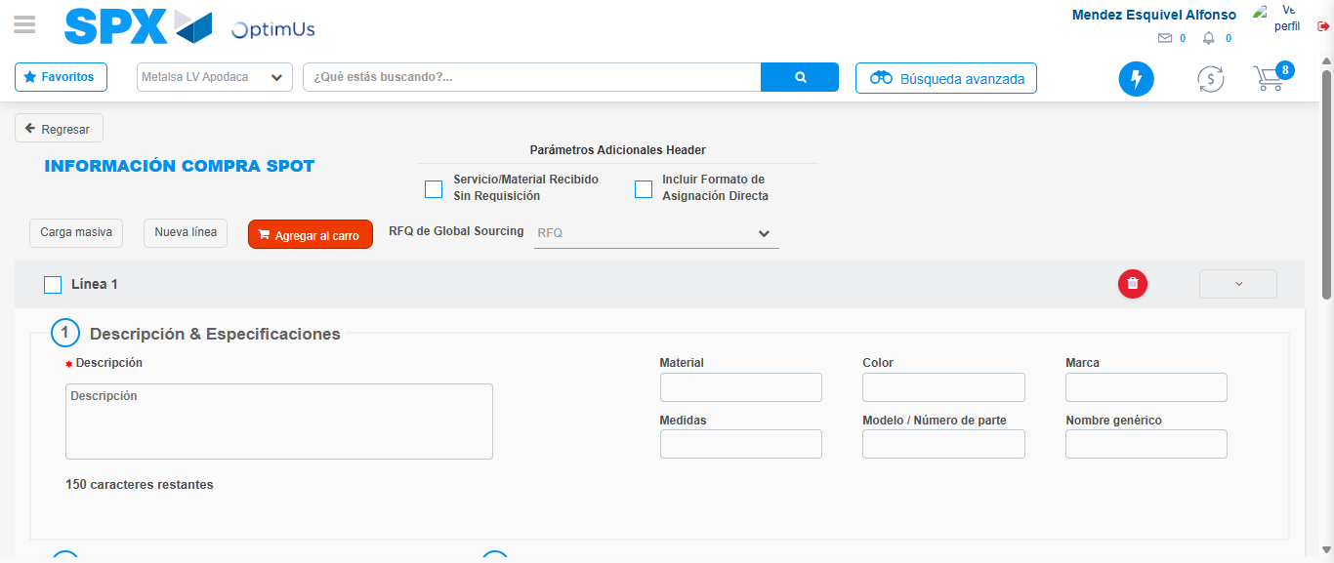Image file-name: QC_Testing-tc006_SPX_Dev5_Crear_Requisicion_Spot_Tipo_Cobro_Proyect_Urgent-1783374626411

Image file-name: QC_Testing-tc006_SPX_Dev5_Crear_Requisicion_Spot_Tipo_Cobro_Proyect_Urgent-1783374626589

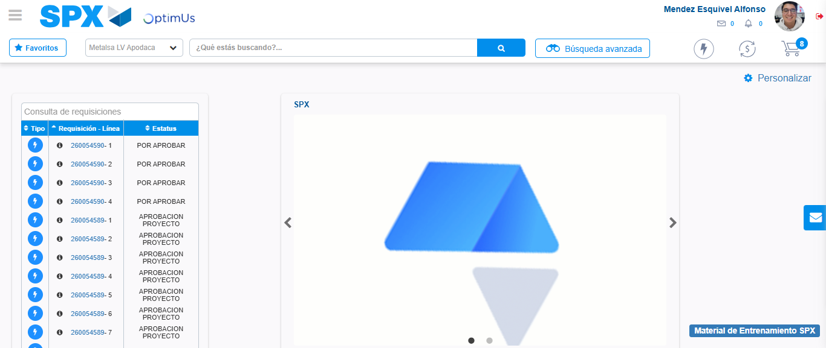Image file-name: QC_Testing-tc006_SPX_Dev5_Crear_Requisicion_Spot_Tipo_Cobro_Proyect_Urgent-1783374647706

Step 8 - Log Out : Log Out SPX
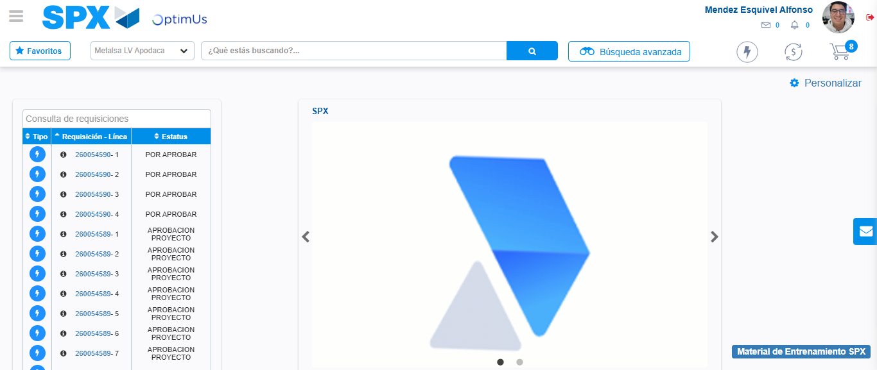Image file-name: QC_Testing-tc006_SPX_Dev5_Crear_Requisicion_Spot_Tipo_Cobro_Proyect_Urgent-1783374647978

